Business Case Template
How to build a business case for a governance, risk and compliance management system

Use this template to know what questions to ask, impress your team and ensure your investment lasts.

Business Case Template

This business case template provides you with a structured framework you can fill out and then present to your management team.
This resource has been provided to you in good faith by the Qualsys Ltd team, to help you to:
- Win leadership buy -in
- Provide benchmarks for the project
- Accelerate momentum towards your strategic objectives
If you would like help filling in any part of the template, contact our team: hello@qualsys.co.uk, we’re happy to be a resource.
All the best,
Qualsys Customer Success Team.
hello@qualsys.co.uk
https://www.qualsys.co.uk
+44(0) 114 282 3338

1.

How to use this template

What you will find in this guide

This business case template provides you with a structured framework you can fill out and then present to your management team. This resource has been provided to you in good faith by the Qualsys Ltd team, to help you to:

- Win leadership buy -in
- Provide benchmarks for the project
- Accelerate momentum towards your strategic objectives

If you would like help filling in any part of the template, contact our team. We’re happy to be a resource.

All the best,
Qualsys Customer Success Team.

+44 (0) 114 282 3338
hello@qualsys.co.uk
www.qualsys.co.uk

2.

Business case template

Executive summary

After analysis of existing processes and systems, meetings with stakeholders at all levels of the organisation, and review of the market, there is a strong strategic, operational and compliance argument for a centralised name of solution you want to implement.
Without an integrated single source of truth, organisations suffer from confusion and inconsistency. Process failure, an inability to effectively communicate and a lack of accurate business intelligence lead to errant decision making and introduce serious risk.

Furthermore, regulators and enforcement organisations, backed by an ever-increasing body of law and regulations demand effective compliance programmes and comprehensive reporting. Against this background, astronomical fines, an explosion in litigation, high profile business failure, catastrophic reputational damage and prison-time are all more commonplace.

A single source of truth will enable the organisation to:

- Prevent Information Silos
Integrated compliance modules to manage processes horizontally across the organisation.

- Access Information Anywhere
A range of Add-ins, APIs and integration services ensure information is available anywhere, at any time.

- View Performance at a Glance
Dashboards, custom reporting and data mining at department, business unit and enterprise level accessed with the click of a button.

- Identify and Manage Risk
Identify, assess and manage risk proactively to build competitive advantage.

- Avoid Penalties and Fines
Best practice, standardised processes, comprehensive audit trails and electronic signatures protect the enterprise and avoid legislative penalties and fines.

- Protect Brand Reputation
Anticipate problems and address them before they take hold with tailorable workflow and escalation.

- Ensure Real-time Business Controls
Real-time, online data input to support optimised decision making. Supply data offline on your devices and sync when back online to support remote working.

Our Vision:
Quality to be embedded into every process at
Our management system software to underpin the growth and ongoing compliance of the business and to reduce the need to scale headcount.
Consolidate and integrate business, quality and compliance processes within a single source of truth.
Increased ROCE and revenue per full-time equivalent.
Employees to be confident they are compliant 24/7.

Why an integrated management system?

Alternative options | Advantages | Disadvantages
Continue with paper-based processes | No upfront costs | Time heavy  Employee resources are consumed propping up the manual system and are diverted from other valuable Quality functions  Valuable resources are wasted  Non-value-added activities are consumed, which negatively impacts quality, customer satisfaction and ultimately cost  Silos  Costs increase over time  Less control
SharePoint | Free | Little control  No integration  Silos
Management system software | Scalable  Full control, better compliance  Long-term, sustainable solution | License, implementation and training fee

Financial appraisal

A fully functioning governance, risk and compliance management solution will pay for itself in months, and deliver ongoing savings for years to come. Cost efficiencies are typically generated from:
a) process efficiencies such as automated workflow and reporting, and
b) risk reduction and lower cost of non-conformity.
Using the below as a starting point, the cost savings over 4 years has been calculated.

Below demonstrates the amount of time is taken using current manual processes and the amount of time is would take to complete the same process using management system software:
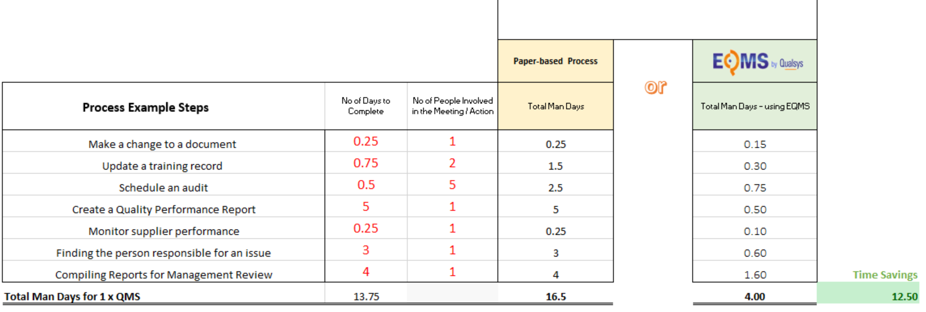
Over a year, efficiency savings would cumulatively reach £312,500.
However, this calculation does not include re-work, delays, other actions / meetings associated with the processes, as by definition this is unpredictable. Furthermore, it does not include Compliance and Risk Reduction and business efficiencies gained from an even more effective process.
Customise this ROI Calculation: https://quality.eqms.co.uk/hubfs/EQMS%20ROI%20Calculation.xlsx

Implement an integrated quality management system
This Business Case recommends that we procure and implement an off-the-shelf Quality Management Software System to allow the effective and efficient management of the key Quality areas at risk:
- Quality Issues and CAPAs,
- Employee Training Records,
- Controlled Documents,
- KPI tracking.
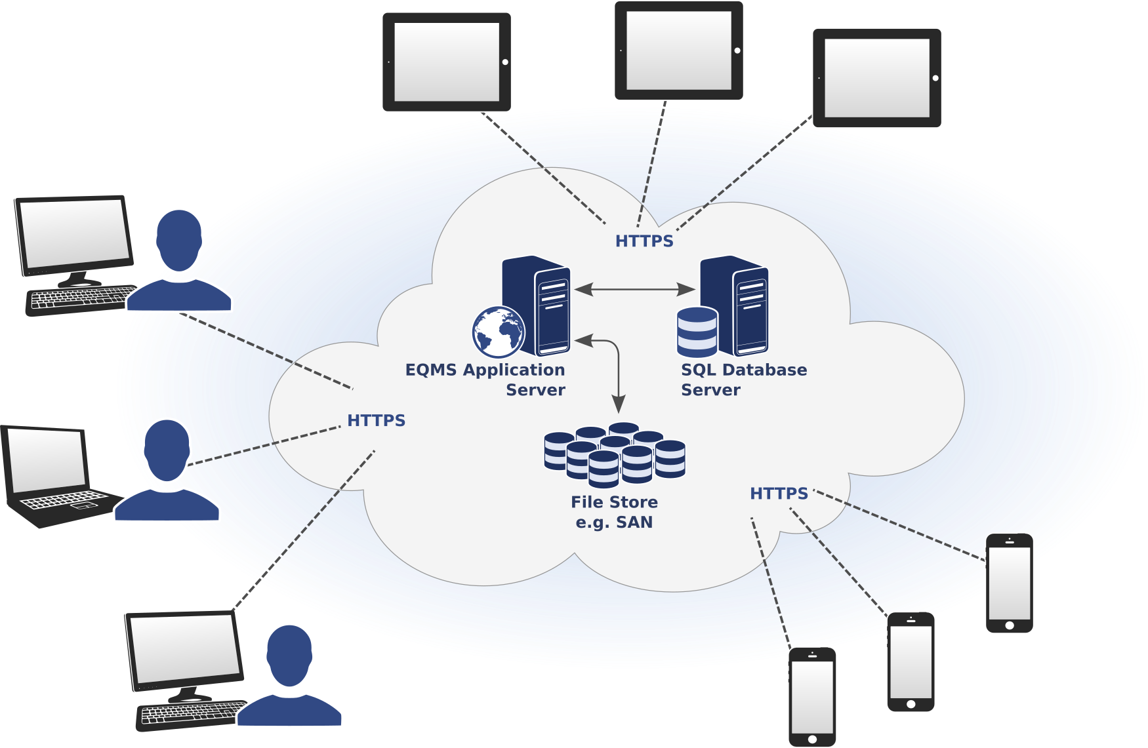

[Improve connectivity with a cloud-based electronic quality management system]

This recommendation is based on the ability of a Quality Management Software System to achieve the key deliverables whilst returning an attractive, and significant, estimated return on investment. Not only does implementing a system address the areas at risk, significant resource utilisation savings and non-resource cost savings can also be achieved by driving efficiency and accuracy.
The benefits to the Business of investing in an electronic QMS far outweigh the cost of implementing and maintaining a new software system; the estimated return on investment is outlined in the table below. As the cost of Good Quality increases, the cost of Poor Quality automatically decreases; there are instant benefits as the compliance profile increases. This business case requests the budget necessary to fund the recommended business option.

Total Benefits
Total Costs
Net Cost/ Gain:

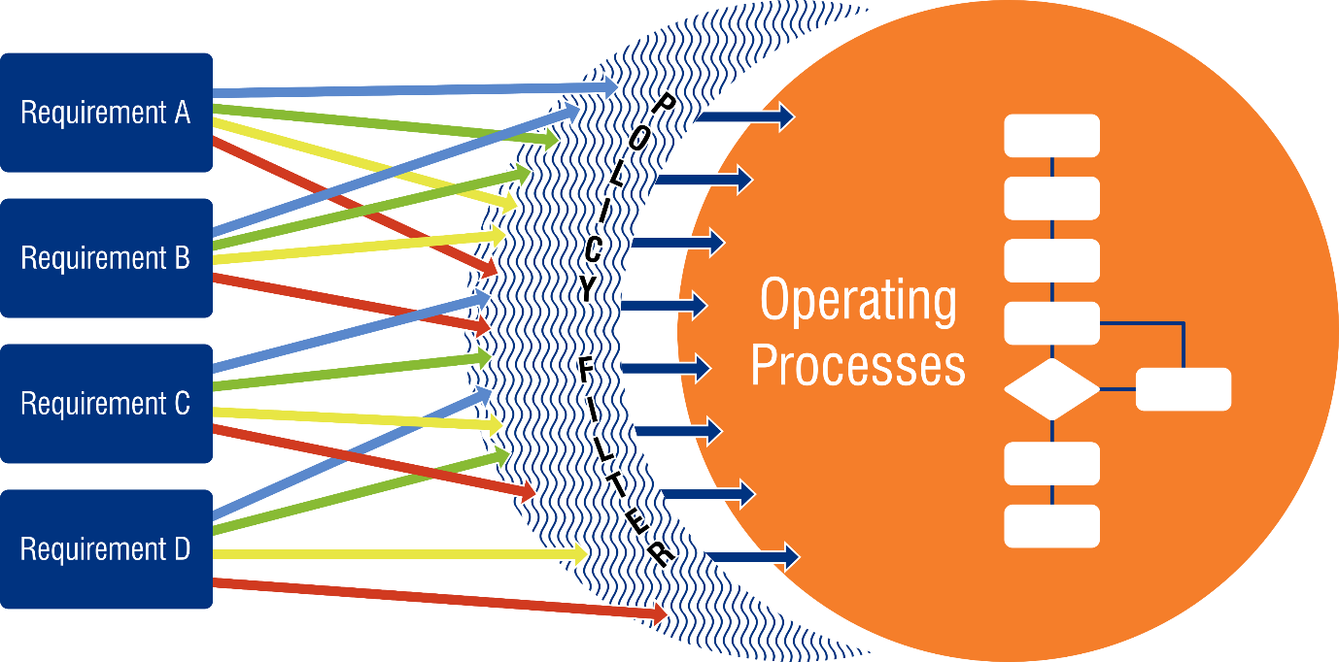
[With an electronic quality management system, various business processes can be managed and controlled centrally]

Benefits
The proposed software system will benefit our company as follows:

The potential benefits that could be achieved by this project, due to the increased visibility and tracking, plus ability to better manage risk and cost savings are broken into Monetary (Hard) and Non-Monetary (Soft) benefits.

Benefits of an electronic management system:
- Assign responsibility | - Improved knowledge sharing
- Scalable – Free end-users | - Centralise control
- Underpin growth & ongoing compliance | - Eliminate the need to scale headcount
- Improve accountability & ownership | - Identify & manage risk
- Monitor business performance | - Maximise investment
- Proactive risk management | - Prepared for audits
- Easier to manage ISO requirements | - Faster decision making
- Reduced overheads | - Control & compliance
- Better stakeholder relationships | - Less frustration for employees
- Demonstrate compliance | - Improved visibility of issues
- Reduce risk of hefty fines | - Demonstrate commitment to quality
- Access anywhere, any time | - Comprehensive reporting
- Reduce risk of non-conformity | - Stronger foundations for growth
- Enhanced reputation | - Reduce poor quality
- Improve customer satisfaction | - Maximise available resources
- Immediate feedback | - Co-ordinate activity across multiple sites
- Deliver consistency | - Automated emails

Monetary
No. | Period of Realisation | Description | Measure | £ Value
1 | Years 1-5 | Cost deferral – Recruitment of an Auditor  As it stands with current systems, meeting the audit activity target of 70% of an auditor’s time would mean employing an additional auditor to ease capacity. The implementation of a software system would remove the need to employ an additional auditor to meet the target. (Based on static company growth) | Quality Time Sheets  Quality Headcount  Quality P&L
2 | Years 1-5 | Removal of Controlled Document courier costs | Quality P&L
3 | Years 1-5 | Removal of Controlled Document copying costs | Quality P&L
4 | Years 2-5 | Removal/reduction of reliance on external training vendor(s), as internally developed training can be loaded / managed in-house. (Based on static company growth) | Quality P&L

Non-Monetary
Period of Realisation | Description | Measure
On delivery | Automated escalation or notification processes in place therefore enhanced response capabilities for quality issues and CAPA. | Monthly Quality Metrics.
On delivery | Consistently accurate KPIs and trending data. | Monthly Quality Metrics.
On delivery | Eliminate lost / missing training records, and enables oversight of training record compliance centrally; therefore reduction in audit/inspection findings. | Monthly Quality Metrics.
On delivery | Estimated 50% employee time saving on completing and maintaining training records electronically, which potentially releases XFTE of resource capacity per year across the company. | Introduction to KPIs.
On delivery | Estimated 50% employee time saving on managing controlled documents electronically, which will allow the Quality Assurance Coordinator to perform other activities, currently being performed by auditors. | Quality Time Sheets
On delivery | Reduced need for face to face regulatory training with associated cost savings for travel / accommodation / time out office. | Monthly Metrics.
On delivery | Significant Quality resource saving by automating aspects of the Controlled Document maintenance and release process. | Quality timesheets.
On delivery | Eliminate lost / missing controlled documents, and enables oversight of controlled document compliance centrally; therefore reduction in audit/inspection findings. | Monthly Quality Metrics.
On delivery | CFR 21 Part 11 compliance for electronic signatures. | System release certificate.
Year 1 | Significantly reduce the risk of regulatory and client critical non-compliance. | Monthly Quality Metrics.
Year 1 | Reduce the risk of revenue loss due to fraud and subsequent restrictions on recruitment / site closures. | Monthly Quality Metrics.  Country P&Ls.
Year 1 | Reduction in inspections / external audit, and subsequent costs. | Monthly Quality Metrics.  Country P&L.
Year 1 | Quizzes to test staff understanding of a controlled document, with pass rates set to ensure complete understanding of a procedure prior to the implementation of the process. | Introduction to KPIs.
Year 1 | Improved customer satisfaction through optimal timely decision making, therefore reduction of customer complaints. | Monthly Quality Metrics.  Client Governance Metrics.
Year 1 | Improved brand image by enhanced reputation for Quality. | Repeat Business.
Year 1 | Greater platform for growth. | Repeat Business.  New Business.
Year 1 | Ensure Quality Management System is best in class and can be used as a selling differentiator. | Monthly Metrics.  New Business.

Vendors
After a thorough evaluation of integrated quality management software vendors, our shortlisted solution providers are:
- Qualsys
- XX
- XX
- XX
- XX

Access: Vendor Scorecard https://quality.eqms.co.uk/hubfs/Vendor_Scorecard-_EQMS.xlsx
Following our vendor analysis, you can see XXX is a strong fit.

About Qualsys

Qualsys provide a complete a governance, risk and compliance management suite which aligns sound governance and operational excellence by consolidating and integrating initiatives across your organisation in a single solution.

The system enables you to manage processes across the organisation – preventing information and process silos and encouraging teams to work to the consistent organisational objectives.

A flexible, highly-configurable, off-the-shelf solution enables you to pick and mix modules to meet the needs of your organisation. The system provides a robust framework for you to manage anything from internal policies to audit programmes, equipment lifecycles to supplier assessment, training requirements to contract change request.

Contact:
Michael Ord, michael.ord@qualsys.co.uk
www.qualsys.co.uk
Read reviews on Capterra
+44 (0) 114 282 3338

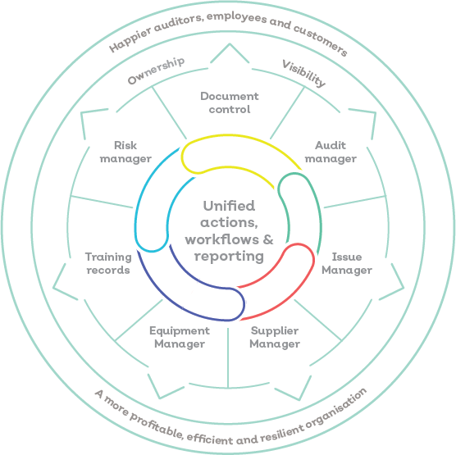
[Integrated modular software solution]

Qualsys Ltd is invested in our success, and actively practices:
- Continuous improvement and learning
- Growth-by-case-study mantra
- Sustained relationships with customers.

Business processes managed in the modular management system solution:
Policies, procedures & processes | Equipment lifecycles
Training records | Supplier relationships
Audits and inspections | Documents & Technical design drawings
Risks | Change requests
Health and safety incidents | Bill of materials
Business reports | Deviations

The vendor has a services team who support the roll-out, implementation and training of software. There is then Account Management support to maximise your return on investment.

Our software is trusted by:
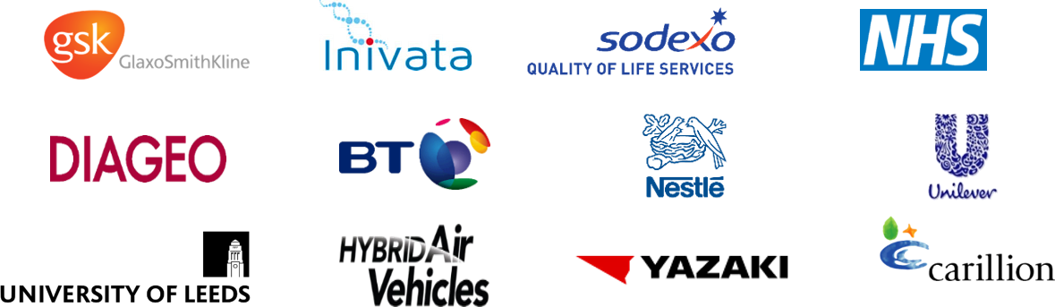

Scope of the project

The first step is to agree the ‘Aims & Objectives’ of the project. Qualsys Ltd engage with key stakeholders to identify and agree how the system will meet your project success criteria:
a) What does success look like to you?
b) What are your objectives?
c) How will we measure success?
This delivers alignment between the quality management system and the strategic goals of the organisation.

https://quality.eqms.co.uk/hubfs/Implementation_Plan.pdf

Project approach

Qualsys provide a Project Scoping Workshop (3 hours) where your team will evaluate a system which has been configured with customer specific data and workflows. This experience provides the benefit of a ‘trained hand’ driving the system whilst your Project Team will focus on evaluating and asking critical questions – the best of both worlds.

Qualsys Ltd offers a choice of ‘Big Bang’, ‘Pilot’ or ‘Phased’ roll-out. Based on the size of the organisation and the number of modules we intend to deploy. The final project plan will be led by the supplier, Qualsys Ltd.

There will be two levels of access:

- Administrator – full access and design capability (XXX concurrent licences, annual licence fee)
- End user - All operators / managers, full access to (free and unlimited)

Administrators: During the initial migration, administrator(s) will be required to cleanse, migrate and upload data onto the system. It’s an opportunity to spring clean, so this is the most time-heavy part of the project yet very valuable. This administrator can come from existing internal resource, or an example job description can be found here:
https://quality.eqms.co.uk/hubfs/Job%20Description%20-%20EQMS%20Administrator.docx.

Alternatively, it is possible to outsource time-heavy activities such as batch upload of documents/records and data migration from legacy systems such as SharePoint or Lotus Notes to Qualsys Ltd. A team of qualified and experienced personnel are available to support at an additional fee.

When setting up the system, Qualsys provide two x systems as standard – 1x Live and 1x UAT (Test) system. All workflows, custom form-fields and permissions are configured with your Project Implementation Manager. This provides an opportunity to ensure the system is set up in the best possible way.

After this, the administrator responsibility will be to maintain the QMS. Duties typically involve:
- Manage approval workflows
- Raise awareness of the system to end-users and act as a point of contact for queries or ideas
- Report on KPIs

The vendor, Qualsys Ltd, also provides training which is geared to creating ‘Internal Champions’, by delivering ‘Train-the-Trainer’ courses to your System Administrators/Managers, who then cascade learning to ‘end-users’. This engenders wider buy-in, a sense of ownership and delivers a greater return on investment.

End Users: Our software is a very user-friendly system, requiring minimal training for end-users. There are a range of materials available online to support end-users to adopt the system. Qualsys also provide a Customer Success team who are on-hand to advise initiatives to drive engagement with your management systems.
Driving Awareness

A team of champions will be required to engage the workforce with the system. This typically includes department heads and members of senior management.

Purchasing strategy
Qualsys work with a software asset finance partner who wrap up training, software and support costs into 36 equal monthly payments.
Free end-users mean the system is highly scalable and will not limit the company as we continue to grow.

Project governance
The project team will be made up of:
- Project Manager (name)
- Internal champions (list)
- Department heads
During the initial go-live period, progress reporting will be managed by the Project Manager and will be communicated on a weekly basis.
After this, all stakeholders will be able to log on to your management system and view performance through the key performance indicator dashboard.

Next Steps
After the project has been signed off by the management team, kick off meeting will begin in the next XXX week (s).

